
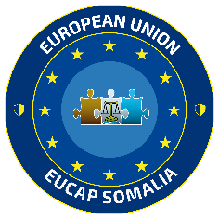
Green Week
EUCAP & EUTM Somalia

 | Day 1 – June 4th  (Wednesday) | Day 2 – June 5th  (Thursday)
08:00 –10:00 | Green Week Opening  Circularity Quiz Kick-off | Green Week Seminar  Recycled Arts&Crafts Exhibit
10:00 – 10:30 | Coffee Break | Coffee Break
10:30 – 11:00 | Clothes and Item Donation  & Hand-Over Photo | Green Week Seminar  Recycled Arts&Crafts Exhibit
12:00 – 13:30 | Lunch Break | Lunch Break
13:30 – 16:30 | Beach Clean-up  & Group Photo | Recycled Arts&Crafts Exhibit  16:00 Quiz Winner announcement  & Award Event Photo

