-

EU GREEN WEEK PARTNER EVENT

Technical meeting on
soil health monitoring
Las Caballerizas,
Arkaute Agri-Food Campus,
Vitoria-Gasteiz
June 10
WELCOME AND GENERAL CONTEXT
09:30 – 09:45
Welcome and institutional messages, Amaia Barredo / Raul Perez Iratxeta (Basque Government)
09:45 – 09:55
Importance of soil health and regulatory framework, Olatz Unamunzaga (NEIKER)
Soil health is a key pillar for agri-food sustainability, biodiversity and climate change mitigation. Its protection and restoration are framed within initiatives such as the EU and Basque soil protection strategies and the new European Soil Monitoring and Resilience Directive.
REGIONAL SCALE MONITORING
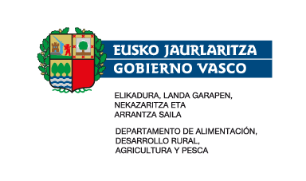
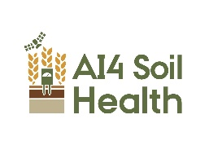


09:55 – 10:25
Results of the pilot sampling of the LURNET Basque soil health monitoring network, Ainara Artetxe / Mercedes Román (NEIKER)
A soil health monitoring network has been designed for the Basque Country, in line with the European Soil Directive. The sampling design follows a stratified random approach based on climatic, soil, and landscape covariates, defining nine soil units and selecting 400 sampling points. Results of physical, chemical, and biological properties will be presented from the pilot sampling carried out in autumn 2025 on cultivated soils.
10:25 – 10:40
BASONET network: 25 years of monitoring Basque forest soils, Alejandro Cantero (HAZI)
Since the Basonet network for sustainable forest management in the Basque Country was established in 2001, hundreds of plots and thousands of forest soil horizons have been measured. This work was carried out by IKT, now HAZI Fundazioa, with funding from the Basque Government. After 25 years, time-series data are now available for around 430 permanent plots distributed across the Basque forest area on a 3 × 3 km grid.

LOCAL SCALE MONITORING
10:40 – 10:55
Visual assessment of soil health in intensively managed forest plantations
(Ander Arias, NEIKER)
Forest operations can cause soil disturbances when carried out improperly. Assessing the impact of these disturbances at stand scale on soil physical properties and on soil organic matter and nitrogen content is complex and costly. In this work, the effectiveness of a rapid and less expensive visual assessment method for the characterization of these disturbances was evaluated.

10:55 – 11:10
Use of spontaneous vegetation cover in a Rioja Alavesa vineyard as a measure to reduce erosion, Ana Aizpurua (NEIKER)
A field experiment has shown that erosion is significantly reduced when using spontaneous vegetation cover as a soil management method. Additionally, it has been verified that organic matter content increases in the first 10 cm of soil after 5 years of maintaining the cover.

11:10 – 11:40 BRUNCH

11:40 – 11:55
Evolution of soil properties over a cereal-legume rotation under conventional and organic systems (2023–2025), Haritz Arriaga (NEIKER)
In a 3-year rotation in which wheat and chickpea were cultivated under conventional and organic systems, the effects of (i) different wheat varieties (bread-making or feed types) and (ii) various fertilization strategies (organic/mineral) on a range of physical, chemical, and biological indicators of soil health were investigated.

11:55 – 12:10
Evidence of regenerative grazing on soil health, Nerea Mandaluniz (NEIKER)
Regenerative grazing, inspired by the patterns of wild herbivores, is a strategy that improves the sustainability of livestock systems and has been studied by NEIKER since 2013 in dairy sheep. Results show increases in grass production, carbon sequestration, and plant diversity, along with improvements in nitrogen cycle microorganisms and water retention.
PARTICIPATORY DYNAMICS
12:10 – 12:40
Co-designing the soil health viewer and a soil health index for decision making, Lur Epelde (NEIKER)
A demonstration of the AI4SoilHealth project’s Soil Health Viewer will be given, along with a methodological framework for developing soil health indices, and workshop participants will be invited to provide feedback as potential users of these tools.

FIELD MEASUREMENT DEMONSTRATION
12:50 – 13:30
Simple methods for soil health assessment without a laboratory, Mikel Anza / Aitor Anitua / Lur Epelde (NEIKER)
Rapid methodologies will be presented, including a mobile application for assessing aggregate stability, a kit for estimating microbial biomass and ecoacoustic microphones to analyze soil fauna activity, as well as other measurements integrated into the LURZAIN participatory science platform.

