EU GREEN WEEK PARTNER EVENT

Deposit Return Systems

Delivering on Circularity Post-PPWR

Permanent Representation of Lithuania to the European Union
10:20 – 10:50 | Security checks and registration
11:00 – 11:10 | Opening by the hosts
11:10 – 11:30 | Overview of the existing DRS landscape in Europe and its achievements  Clarissa Morawski, CEO and Co-Founder, Reloop
11:30 – 11:50 | DRS delivering on the PPWR targets – policy perspective  Wolfgang Trunk, Team leader in DG ENV- Unit B.3
11:50 – 12:10 | National DRS perspective: Lithuania – a success case  Speaker TBC
12:10 – 12:30 | Successful design parameters of DRS and their adjustment to the local context  Raymond Gianotten, DRS consultant, OLHC
12:30 – 13:45 | Conclusion and networking lunch
Rue Belliard 41-41, 1040 Brussels, Belgium
02 June 2025

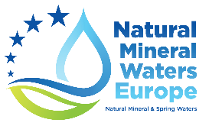 | 