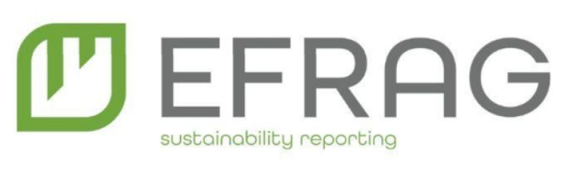
EU Green Week 2025
EFRAG Hosts: Insights from 1st year of ESRS E5 (Resource Use and Circular Economy) Reporting
Monday 3.6.2025
10:00-12:00
Hybris event – Physical (upon approval of [participation) & Online

During the EU Green Week, EFRAG will present valuable insights and lessons learnt from the first year of the European Sustainability Reporting Standards (ESRS) implementation. The event will feature EFRAG’s analysis on Circular Economy (ESRS E5) reporting, highlighting good practices, challenges, future improvements, and lessons learnt. This discussion will provide essential input for the envisaged revision of the first set of ESRS under the Omnibus proposals. Join us for a round table discussion with key stakeholders, to explore these findings and share experiences.
Agenda:
10:00 Greetings – Ms. Pedro Faria, Environment Lead, EFRAG
10:15 Opening Lecture – Dr. Liad Ortar, Senior Technical Manager (E5 lead), EFRAG
State of Circularity in the EU facing global environmental challenges
10:45 E5 team, EFRAG
Presenting E5 Benchmark Results
11:15 Response from a Key-Note speaker (tbd)
11:30 Q&A
12:00 Closing Remarks – Dr. Liad Ortar, Senior Technical Manager (E5 lead), EFRAG

