
CIRCULARMENTE, the Región de Murcia’s flagship business sustainability event, returns for its second edition, offering businesses a unique opportunity to prepare themselves for the necessary transition towards circularity. Organised by the REGIÓN DE MURCIA ECONOMIC DEVELOPMENT AGENCY (INFO) in collaboration with CETENMA and the ISAAC PERAL FOUNDATION, this European Green Week parallel event will be held in the Víctor Villegas Auditorium in Murcia, on June 17, 2025.
Following a year of profound political change which has seen the European Union change its approach to sustainability, prioritizing competitiveness, CIRCULARMENTE seeks to explore and debate how businesses in the region can and should see these changes as an opportunity, with the event covering the most essential topics. With a practical and collaborative focus, the event seeks to inform, inspire and guide businesses on their path to a sustainable transition, highlighting examples of best practices and offering opportunities to establish contacts and engage in business-to-business collaboration.
CIRCULARMENTE will bring together experts, businesses, and authorities to exchange knowledge and experiences relating to sustainability, encouraging the region’s businesses to implement green strategies.
On the MAIN STAGE of the Victor Vallegas Auditorium, a series of diverse keynote addresses and roundtable discussions will take place, while complimentary activities are held in the NETWORKING SPACE. In addition, a SUCCESS STORY SITE VISIT will allow participants to see first-hand an inspirational example of sustainability in the region in a more informal setting, facilitating learning and innovation.
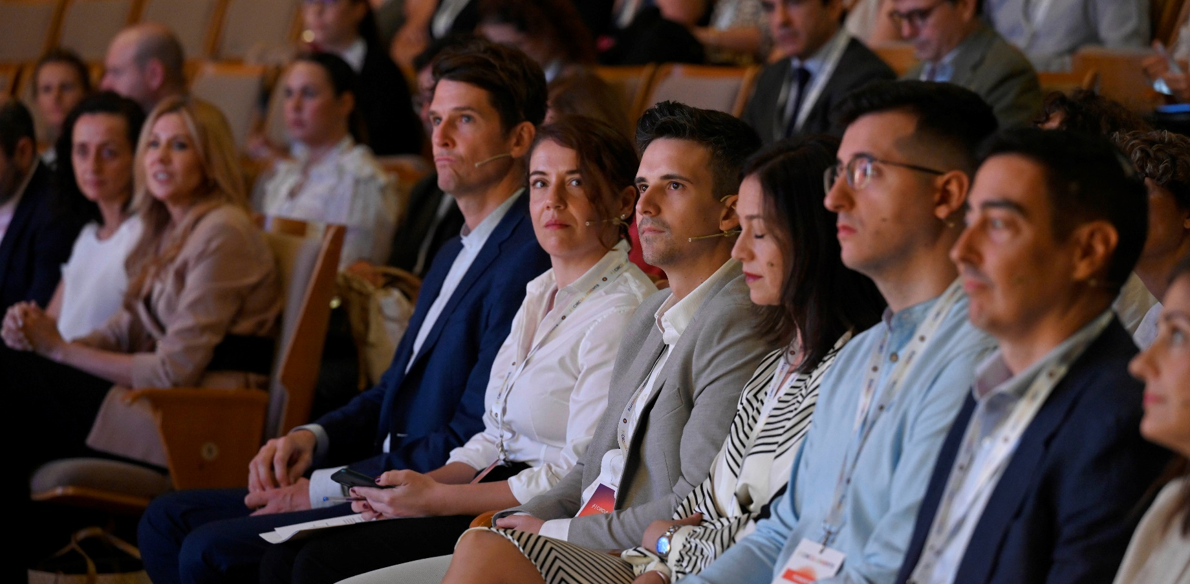

ESCENARIO PRINCIPAL
9:30am Registry of attendees
………………………………………………………………………………………………………………………………
10:00am Welcome
Representative of the Business, Employment and Social Economy Department of the Government Región de Murcia (CARM)
………………………………………………………………………………………………………………………………

10:15am The Competitiveness Compass: The Route Towards Business Success

Representative of the European Commission
………………………………………………………………………………………………………………..………….
10:20am Main Keynote. Redefining business success with transformative solutions
……………………………………………………………………………………………...……………………………..
10:45am The Región de Murcia’s Plan for Business Sustainability
Representative of INFO
……………………………………………………………………………………………………………………………..
11:00am Making the Most of Available Funding for the Green Business Transition – Round Table
An exploration of the funding tools and mechanisms that are available for businesses in Spain that are looking to adopt a circular business model in which success stories and future opportunities will be discussed. The panel will feature representatives of regional businesses from a range of different sectors.
Keynote and Moderator: Alejandro Dorado (Commissioner, Ministry for the Ecological Transition and the Demographic Challenge)
………………………………………………………………………………………………………………………………
11:45am Networking Coffee Break
………………………………………………………………………………………………………………………………
12:15pm From Regulations to Opportunities and Competitive Positioning. The Success Story of the Basque Country – Round Table
We explore how environmental regulations, far from being an obstacle, can in fact be a strategic boost for business innovation and competitiveness. Using the example of the Basque Country, key rules will be analysed and we will learn how anticipating regulations can unlock opportunities. A conversation between leaders of institutions and businesses that are already benefiting from the new legislative framework.
Keynote and moderator: (27) José María Fernández Alcalá | LinkedIn (Director of Circular Economy at Ihobe, The Basque Government Public Society of Environmental Management)
………………………………………………………………………………………………………………………………

1:30pm Circularity Strategies for your Businesses – Round Table
We analyse how the implementation of sustainability strategies in businesses or environmental certifications allow businesses to comprehensively demonstrate their commitment to sustainability and the Circular Economy, bringing added value, distinctness and access to new markets. Participants of the round table debate include representatives of organizations with defined strategies and certifications such as Cradle to Cradle, EMAS, EcoLabel and BCorp.
Context and moderation: (25) Hasler Iglesias | LinkedIn
………………………………………………………………………………………………………………………………
2pm Morning session ends
………………………………………………………………………………………………………………………………
4pm-5:15pm Double Materiality and ESG21 Standard - Workshop
With contributions from sustainability experts, the session will be centered around resolving fundamental questions about the new ESG21 standard, the Omnibus Package, and how businesses can advance their certification and meet sustainability standards. We will explore the concept of ‘double materiality’ in depth, a key requirement for evaluating the impact of business activity not only in terms of finances, but also in terms of its relation with the environment and society as a whole.
Moderator: Patricio Valverde (Managing Director, Isaac Peral Foundation)



PARALLEL ACTIVITIES
Inspiring sustainability practices will be showcased Next to the main hall will be a dedicated area. With a practical and collaborative focus, the space will inspire and inform, giving a central role to best business practices and offering opportunities for making useful contacts, with dedicated coordinators present to ensure all participants can actively engage to take advantage of the networking opportunities.

8am-2pm Circular Economy ‘Newcomers Register’
Live ‘Newcomers Registration’ where first-time attendees can fill out a check list to identify potential new additions to the INFO Región de Murcia Dynamic Catalogue of Circular Economy Best Practices. This activity will also help attendees to familiarise themselves with the people behind the Catalogue of Best Practices.
………………………………………………………………………………………………………………………………
8am-2pm Best Practices, Products, Solutions, and R&D
This space will bring together a wide variety of innovative businesses that are applying Circular Economy and sustainable principles in their products and services. From the food, cosmetics and logistics sectors to sectors such as energy, construction, and chemical manufacturing, these organisations will put their tangible practices on display, including Ecodesign, remanufacture, digital traceability or the efficient use of resources. All examples exemplify a commitment to transforming their business models to have a positive social and environmental impact. In addition, regional R&D projects with transferable and useful results will be on display for attendees to learn about their potential power for driving the green business transition.
………………………………………………………………………………………………………………………………
8am-2pm Express Meetings
Area for meetings between agents of change (offering solutions) and businesses (searching sustainable solutions).
………………………………………………………………………………………………………………………………
11am-2pm Recording of interviews with businesses and relevant figures
Recording of interviews

SUCCESS STORY SITE VISIT (16-06-2025)
A study visit to a business representing a success story in sustainability, complimenting the event, allowing for a less formal atmosphere for learning more about the best business sustainability practices found in Murcia.
